R8 Ego centric camera specification
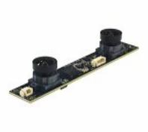
Fixed Focus USB 2.0 Camera Module
1080P M12*P0 5 SC235HGS
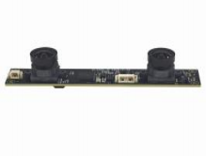

This R8 2MP dual-lens stereo camera module is purpose-built for egocentric data collection, robot learning, and embodied AI research. Featuring dual global shutter sensors, it outputs synchronized stereo video at 30fps — eliminating rolling shutter distortion for reliable stereo matching and depth estimation. Hardware-triggered synchronization ensures pixel-perfect frame alignment between left and right cameras. An integrated 6-axis IMU delivers configurable sampling at 100/200/500Hz, hardware-timestamped and synchronized with camera frames at nanosecond level for drift-free visual -inertial fusion. Each unit includes a unique factory calibration file with intrinsics, distortion coefficients, and extrinsics — eliminating onsite setup. Every frame and IMU sample shares unified hardware timestamps with complete SDK/API support. Plug-and-play USB 2.0 with cross-platform SDK for Windows, Linux, and ROS enables rapid deployment.

R8 Key Features:
l Global Shutter ——All pixels expose simultaneously, eliminating rolling shutter distortion and motion artifacts during fast hand/body movement. Ensures geometrically intact stereo frames for reliable depth estimation and VIO/SLAM front-end processing.
l Built-in 6-Axis IMU – Simplified VIO Integration
Integrated accelerometer and gyroscope eliminates external inertial sensors. Provides motion- compensation data essential for VIO and SLAM pipelines without additional system complexity.
l Factory Calibration – Plug and Play, No Onsite Setup
Unique calibration file per unit — intrinsics, distortion coefficients, and stereo extrinsics.
Eliminates checkerboard-based calibration, reduces deployment time from hours to minutes.
l Unified Hardware Timestamp – Dataset-Ready Precision
Every camera frame and every IMU sample shares the same hardware clock, achieving
nanosecond-level alignment. Meets the precision standards required for professional egocentric benchmarks and VIO pipelines. Complete SDK/API provided for seamless integration.

1080P M12*0.5P SC235HGS Fixed Focus USB 2.0 Camera Module

Model: | R8
Resolution | 1600*1200
Frame Rate | 30 fps
Sensor Size | 1/2.6"
Pixel Size | 3.0μm*3.0μm
Dynamic Range | Linear mode: 61.56 dB / HDR mode: 91.56 dB
FOV | D= 180°/H=115°/V=80°
Lens TTL | 15.15±0.3mm
Focus Type | Fixed Focus
Interface | USB 2.0
Output Format | H.264/H.265
Auto Control | Saturation, Contrast, Acutance White Balance, Exposure
Function Description | Dual-camera synchronization / Dual-camera  ranging / Dual-camera calibration / 3D  reconstruction / VR vision / Depth detection
Voltage | DC 5V
Working Current | MAX 320mA
PCB Size | 100*94*60mm
Hardware Synchronization | All cameras synchronized to a common hardware  trigger/shutter signal
IMU | Built-in 6-axis IMU in Head and Wrist units where  required
IMU Sampling data | 100/200/500HZ
Timestamp | Unified timestamp for all camera frames and IMU
SDK/API | SDK/API to be provided
Calibration Data | Camera intrinsic parameters + distortion  coefficients + extrinsic parameters where  applicable
Working Temperature | 0°C to +60°C
Storage Temperature | -20°C to +70°C
Mount | M12*P0.5mm
Compatibility with Windows, Android, Mac OS, Linux, or Raspberry Pi



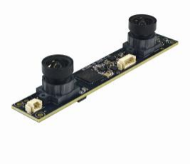

Top View

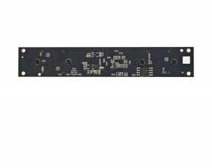

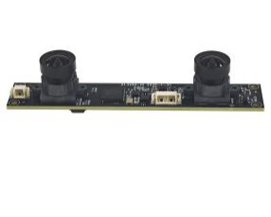

Side View

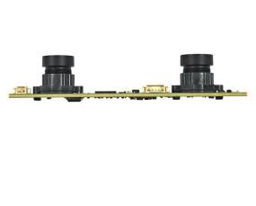

Application Built for Egocentric Data Collection


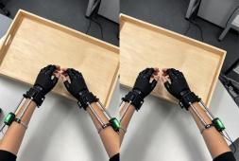
R8 Head-Mounted Egocentric Capture — Record What the Human Sees


From kitchens to factories, lab to offices — Ego Camera R8 is designed for large-scale deployment.
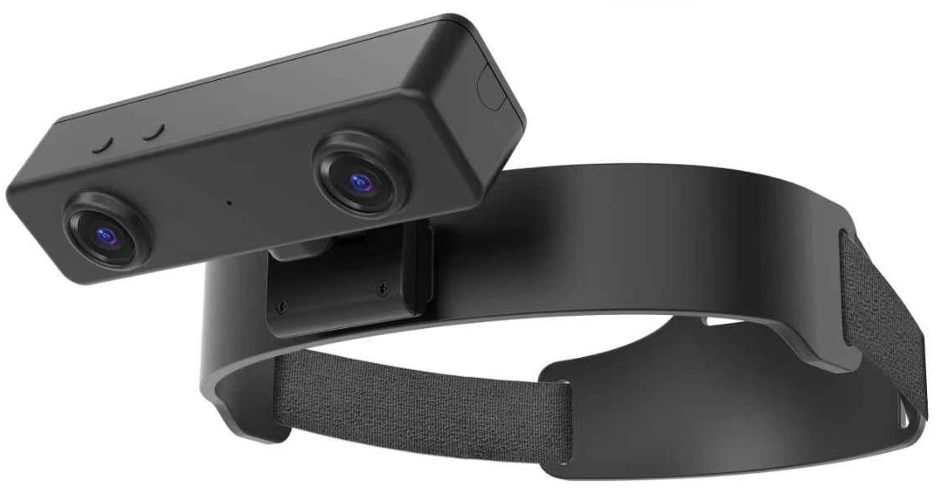

Built for human demonstration capture, embodied AI, and VIO/SLAM. Head-Mounted
◆ Global Shutter ◆ Hardware Sync ◆ Factory Pre-Calibrated

FORMAT | RESOLUTION | FRAME RATE
FORMAT | RESOLUTION | USB 2.0
MJPG | 1920 x 1080 (2MP) | 30 FPS
MJPG | 1280 x 720 (720 HD) | 30 FPS
MJPG | 640 x 480 (VGA) | 30 FPS
YUY2 | 1920 x 1080 (1080P) | 15 FPS
YUY2 | 1280 x 720 (720) | 30 FPS
YUY2 | 640 x 480 (VGA) | 30 FPS

Lens Specifications

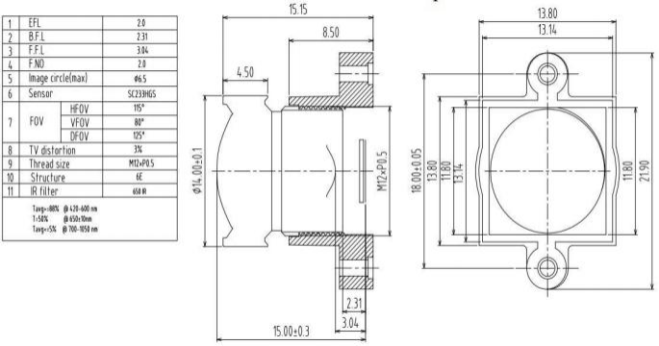

Dimension

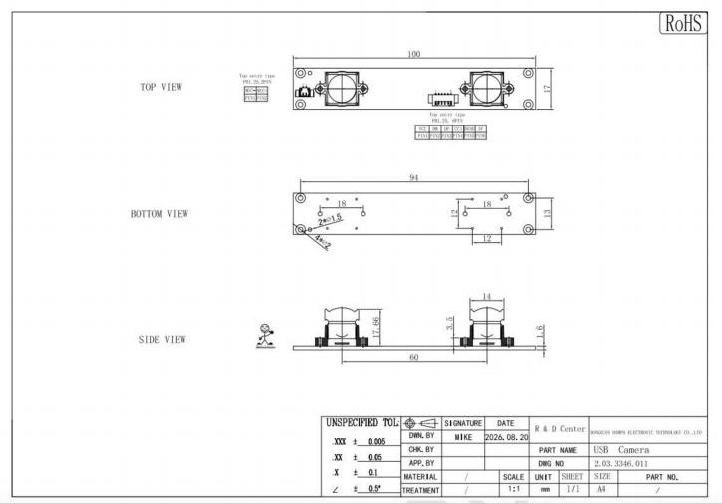

Camera Reliability Test

Reliability Inspection Item |  |  | Testing Method | Acceptance Criteria
Category |  | Item | Testing Method | Acceptance Criteria
Environmental | Storage  Temperature | High 60°C 96 Hours | Temperature Chamber | No Abnormal Situation
Environmental | Storage  Temperature | Low -20°C 96 Hours | Temperature Chamber | No Abnormal Situation
Environmental | Operation  Temperature | High 60°C 24 Hours | Temperature Chamber | No Abnormal Situation
Environmental | Operation  Temperature | Low -20°C 24 Hours | Temperature Chamber | No Abnormal Situation
Environmental | Humidity | 60°C 80% 24 Hours | Temperature Chamber | No Abnormal Situation
Environmental | Thermal Shock | High 60°C 0.5 Hours Low -20 °C 0.5 Hours Cycling in 24 Hours | Temperature Chamber | No Abnormal Situation
Physical | Drop Test  (Free Falling) | Without Package 60 cm | 10 Times on Wood Floor | Electrically Functional
Physical | Drop Test  (Free Falling) | With Package 60cm | 10 Times on Wood Floor | Electrically Functional
Physical | Vibration Test | 50Hz X-Axis 2mm 30min | Vibration Table | Electrically Functional
Physical | Vibration Test | 50Hz Y-Axis 2mm 30min | Vibration Table | Electrically Functional
Physical | Vibration Test | 50Hz Z-Axis 2mm 30min | Vibration Table | Electrically Functional
Physical | Cable Tensile  Strength Test | Loading Weight 4 kg  60 Seconds  Cycling in 24 Hours | Tensile Testing Machine | Electrically Functional
Electrical | ESD Test | Contact Discharge 2 KV | ESD Testing Machine | Electrically Functional
Electrical | ESD Test | Air Discharge 4 KV | ESD Testing Machine | Electrically Functional
Electrical | Aging Test | On/ Off 30 Seconds Cycling in 24 Hours | Power Switch | Electrically Functional
Electrical | USB Connector | On/Off 250 Times | Plug and Unplug | Electrically Functional

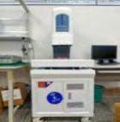
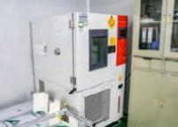
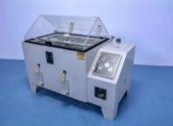
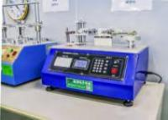

Camera Inspection Standard

Inspection Item |  |  | Inspection Method | Standard of Inspection
Category |  | Item | Inspection Method | Standard of Inspection
Appearance | FPC/ PCB | Color | The Naked Eye | Major Difference is Not Allowed.
Appearance | FPC/ PCB | Be Torn/Chopped | The Naked Eye | Copper Crack Exposure is Not Allowed.
Appearance | FPC/ PCB | Marking | The Naked Eye | Clear, Recognizable (Within 30cm Distance)
Appearance | Holder | Scratches | The Naked Eye | The Inside Crack Exposure is Not Allowed
Appearance | Holder | Gap | The Naked Eye | Meet the Height Standard
Appearance | Holder | Screw | The Naked Eye | Make Sure Screws Are Presented (If Any)
Appearance | Holder | Damage | The Naked Eye | The Inside Crack Exposure is Not Allowed
Appearance | Lens | Scratch | The Naked Eye | No Effect On Resolution Standard
Appearance | Lens | Contamination | The Naked Eye | No Effect On Resolution Standard
Appearance | Lens | Oil Film | The Naked Eye | No Effect On Resolution Standard
Appearance | Lens | Cover Tape | The Naked Eye | No Issue On Appearance.
Function | Image | No Communication | Test Board | Not Allowed
Function | Image | Bright Pixel | Black Board | Not Allowed In the Image Center
Function | Image | Dark Pixel | White board | Not Allowed In the Image Center
Function | Image | Blurry | The Naked Eye | Not Allowed
Function | Image | No Image | The Naked Eye | Not Allowed
Function | Image | Vertical Line | The Naked Eye | Not Allowed
Function | Image | Horizontal Line | The Naked Eye | Not Allowed
Function | Image | Light Leakage | The Naked Eye | Not Allowed
Function | Image | Blinking Image | The Naked Eye | Not Allowed
Function | Image | Bruise | Inspection Jig | Not Allowed
Function | Image | Resolution | Chart | Follows Outgoing Inspection Chart Standard
Function | Image | Color | The Naked Eye | No Issue
Function | Image | Noise | The Naked Eye | Not Allowed
Function | Image | Corner Dark | The Naked Eye | Less Than 100px By 100px
Function | Image | Color Resolution | The Naked Eye | No Issue
Dimension |  | Height | The Naked Eye | Follows Approval Data Sheet
 |  | Width | The Naked Eye | Follows Approval Data Sheet
 |  | Length | The Naked Eye | Follows Approval Data Sheet
 |  | Overall | The Naked Eye | Follows Approval Data Sheet

